CUONG ASSIGNED MID-TERM TASKS
My tasks:
- 1.2. Review at least three models, algorithms, or approaches related to the project topic.
- 1.4. Compare the advantages, disadvantages, and applicability of the reviewed models/approaches to the project.
- 2.3. Present the data preparation process, including segmentation, normalization, noise reduction, labeling, and dataset splitting.
- 3.1. Present the architecture or workflow of the proposed solution.

1.2. Review of Related Models and Approaches
Common preprocessing steps: → audio → mono conversion → resampling to 16 kHz → fixed-length 1-second segmentation → optional speech alignment → noise handling → amplitude normalization → label mapping → official split → training-only augmentation → feature extraction.

- MFCC + CNN:

Audio → Preprocessing → MFCC → CNN → Global Average Pooling → Command

MFCC provides a compact feature representation and serves as an MFCC-based baseline. This is a lightweight and fast approach, but it may lose some detailed time-frequency information.

- Input feature: MFCC coefficients. Compact representation of the speech spectrum.
- Preprocessing dependency: stable sampling rate and fixed-length waveform are required before MFCC extraction.
- Model role: CNN learns local patterns from the MFCC map.
- Useful as a lightweight baseline. Fast training, small model, simple comparison point.
- Limitation: MFCC compresses the spectrum. Some fine time-frequency information can be lost.

- Log-Mel + CNN:

Audio → Log-Mel Spectrogram → CNN → Fully Connected Layer → Command

CNN learns local acoustic patterns directly from the Log-Mel spectrogram. It provides a good balance between accuracy, model size, and inference speed for short speech commands.

- Input feature: Log-Mel spectrogram. Time axis and frequency axis are both visible.
- Model role: CNN detects local acoustic shapes, such as energy changes and frequency bands.
- Suitable for short commands because command clips are fixed-length and word-level.
- Good baseline for practical deployment. Simple architecture and low inference cost.
- Limitation: temporal dependencies are modeled only indirectly through convolution and pooling.

- CRNN (CNN-GRU):

Audio → Log-Mel Spectrogram → CNN → Reshape to time sequence → 2-Layer GRU → Temporal Mean Pooling → LayerNorm + Dropout + Linear → Command

CNN extracts local spectral features, the GRU model temporal dependencies across the speech frames. CRNN is more suitable for longer or more complex speech sequences, but it requires more computation and training time.

- Input feature: Log-Mel spectrogram.
- CNN part: extracts local time-frequency features.
- GRU part: reads the remaining frame sequence and models temporal changes.
- Mean pooling: combines frame-level outputs into one command representation.
- Suitable when the word has useful temporal structure, such as beginning sound, vowel part, and ending sound.
- Limitation: more parameters and more computation than CNN baselines.

Approach | Results
MFCC + CNN | 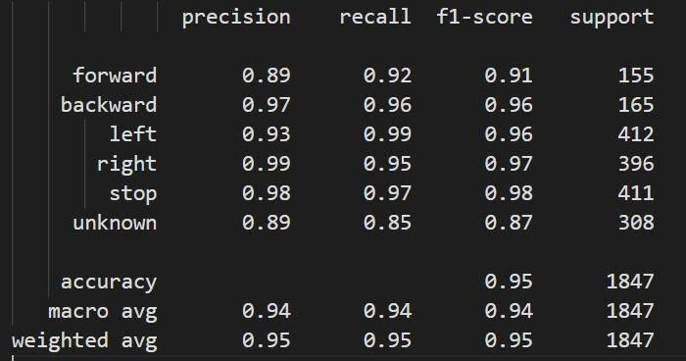
Log-Mel + CNN | 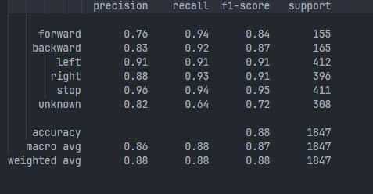
Log-Mel + CRNN (CNN-GRU) | 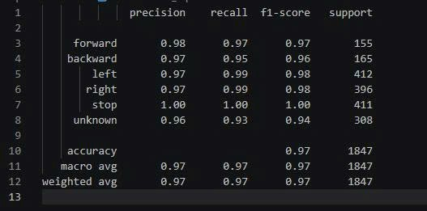

1.4. Comparison and Applicability to the Project
Criterion | MFCC + CNN | Log-Mel + CNN | Log-Mel + CNN-GRU CRNN
Feature | Handcrafted MFCC features; compact representation. | Log-Mel spectrogram with clear time-frequency structure. | Log-Mel features followed by convolution and recurrent layers.
Model size | Small, ~ 23.8K parameters | Small, ~ 23.8K parameters | Larger, 370,038 parameters
Training cost | Low and fast to train. | Moderate and practical for the current dataset. | Higher because recurrent layers increase computation.
Inference latency | Low; suitable for limited hardware. | Low; efficient on a CPU for short clips. | Higher than the CNN baselines, but still suitable for real-time CPU inference at ~ 4.84 ms/sample
Advantages | Lightweight, fast to train, and suitable for limited resources. MFCC features are compact and easy to compute. | Simple and practical baseline. Log-Mel preserves clearer time-frequency patterns and works efficiently for short speech commands. | Combines strong local feature extraction with temporal modeling. Better captures sequential information across speech frames.
Disadvantages | MFCC retains less detailed time-frequency information and may limit performance compared with Log-Mel-based models | Temporal dependencies are modeled only indirectly through convolution and pooling | Larger model size, higher training cost, and higher inference cost than the CNN baselines.

2.3. Data Preparation Process
- Dataset used: Google Speech Commands.
- Target classes: forward, backward, left, right, stop, and unknown.
- Process pipeline:
Google Speech Commands
Raw audio waveform
→ audio loading
→ mono conversion
→ resampling to 16 kHz
→ fixed-length 1-second segmentation
→ optional speech alignment
→ noise handling
→ amplitude normalization
→ label mapping
→ official split
→ training-only augmentation
→ feature extraction.
2.3.1. Audio loading and format standardization
- Input files are WAV clips from Google Speech Commands or user recordings.
- Each file is loaded as a waveform tensor.
- Stereo audio is converted to mono by averaging channels.
- All audio is resampled to 16 kHz.
- Purpose: same audio format before any model feature extraction.
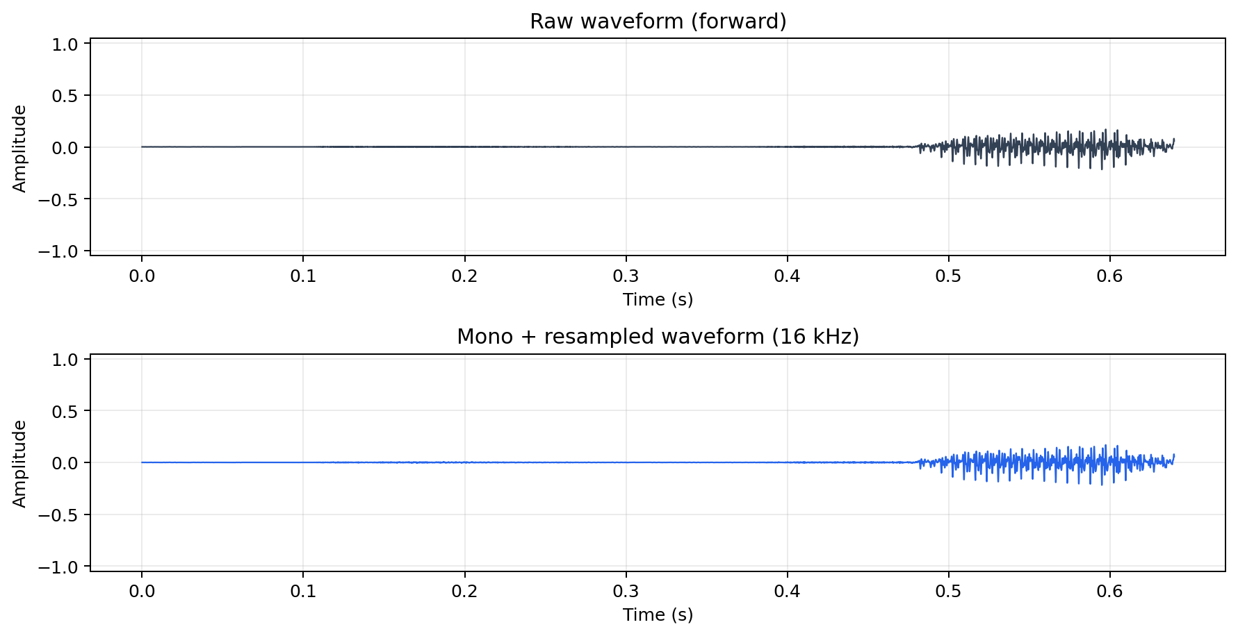

2.3.2. Segmentation and fixed-length windowing
- The command model expects a fixed-size input.
- Each command is converted to 1 second, equal to 16,000 samples at 16 kHz.
- If the recording is shorter than 1 second, zero padding is added.
- If the recording is longer than 1 second, the signal is cropped.
- Speech Commands clips are already word-level clips. Therefore segmentation here means fixed-length command windowing, not sentence-level word segmentation.
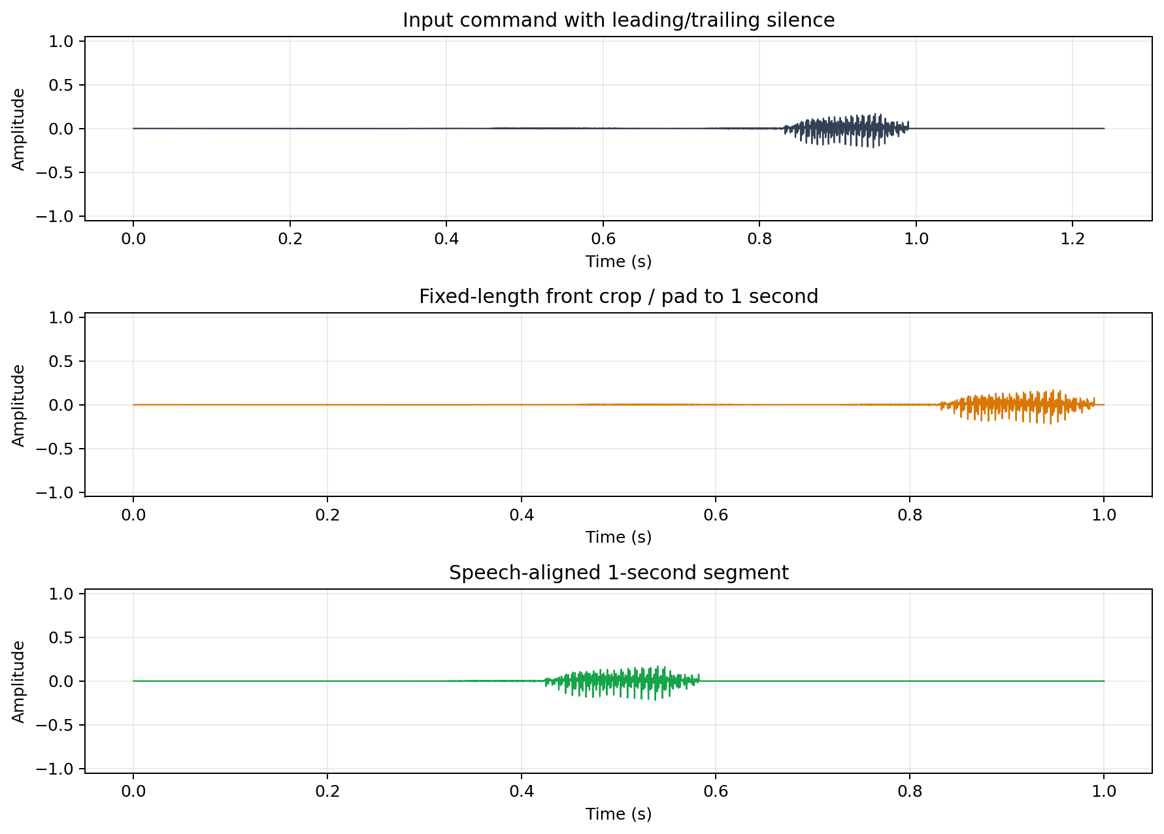

2.3.3. Speech alignment
- Some recordings contain silence before or after the actual word.
- Active speech is estimated from short-frame RMS energy.
- The strongest speech region is centered inside the 1-second window.
- This reduces the case where the important speech part is cut by front cropping.
- Alignment is optional and controlled by config.

2.3.4. Noise handling / noise reduction
- Real microphone input can contain fan noise, room noise, or electrical noise.
- A simple stationary noise reduction step is included.
- The method estimates a low-energy spectral profile and subtracts part of it from the signal spectrum.
- This is basic noise handling, not a separate denoising model.
- Purpose: reduce constant background noise before feature extraction.
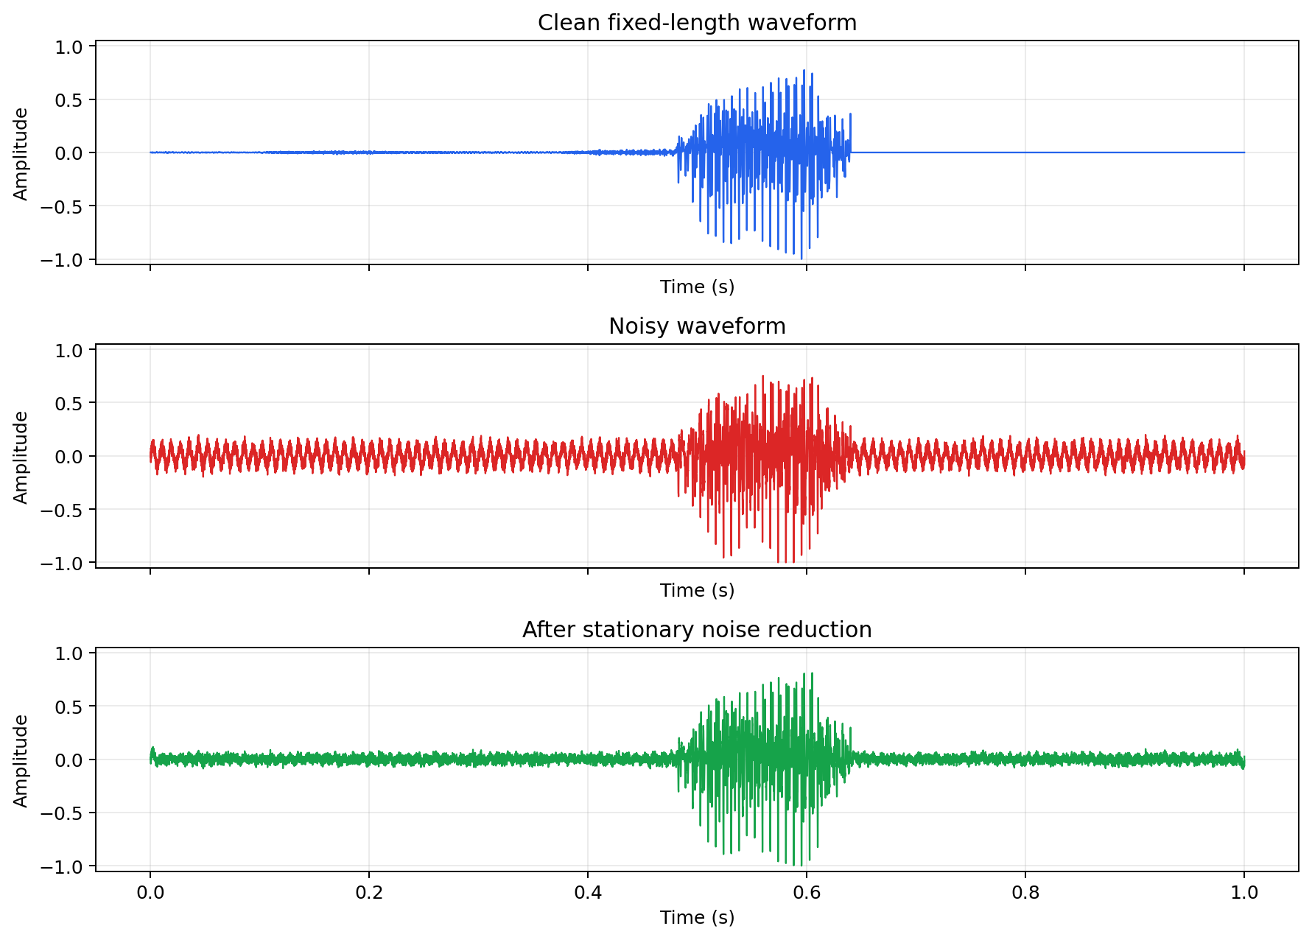
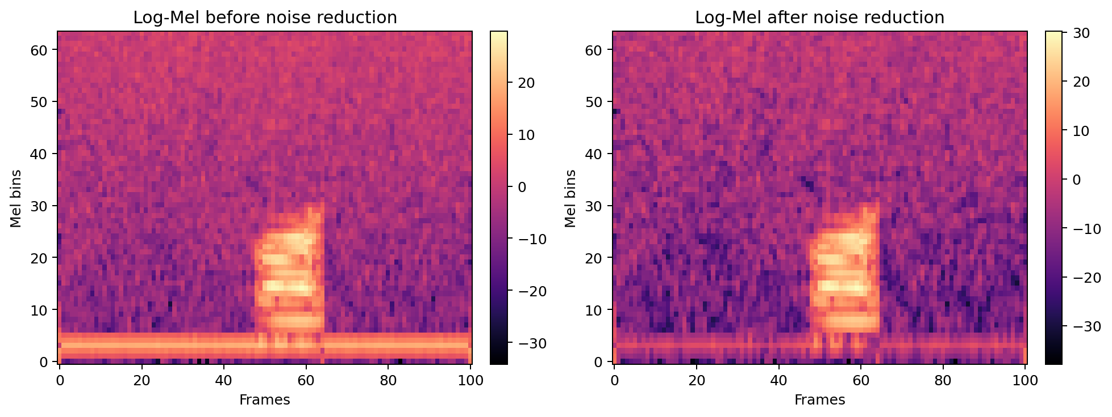

2.3.5. Amplitude normalization
- Different speakers and microphones produce different volume levels.
- Peak amplitude normalization scales the waveform by its maximum absolute value.
- The signal range becomes more consistent across samples.
- This prevents volume from becoming an unwanted dominant factor.
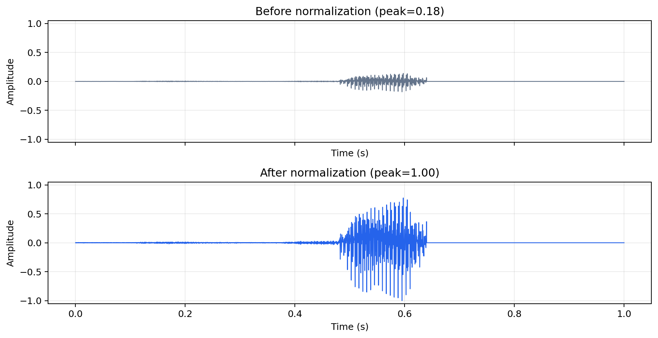

2.3.6. Label mapping and unknown class
- Target commands: forward, backward, left, right, stop.
- Other words are mapped to unknown.
- The unknown class helps the system ignore non-navigation commands.
- The command recognizer therefore has six classes: forward, backward, left, right, stop, unknown.
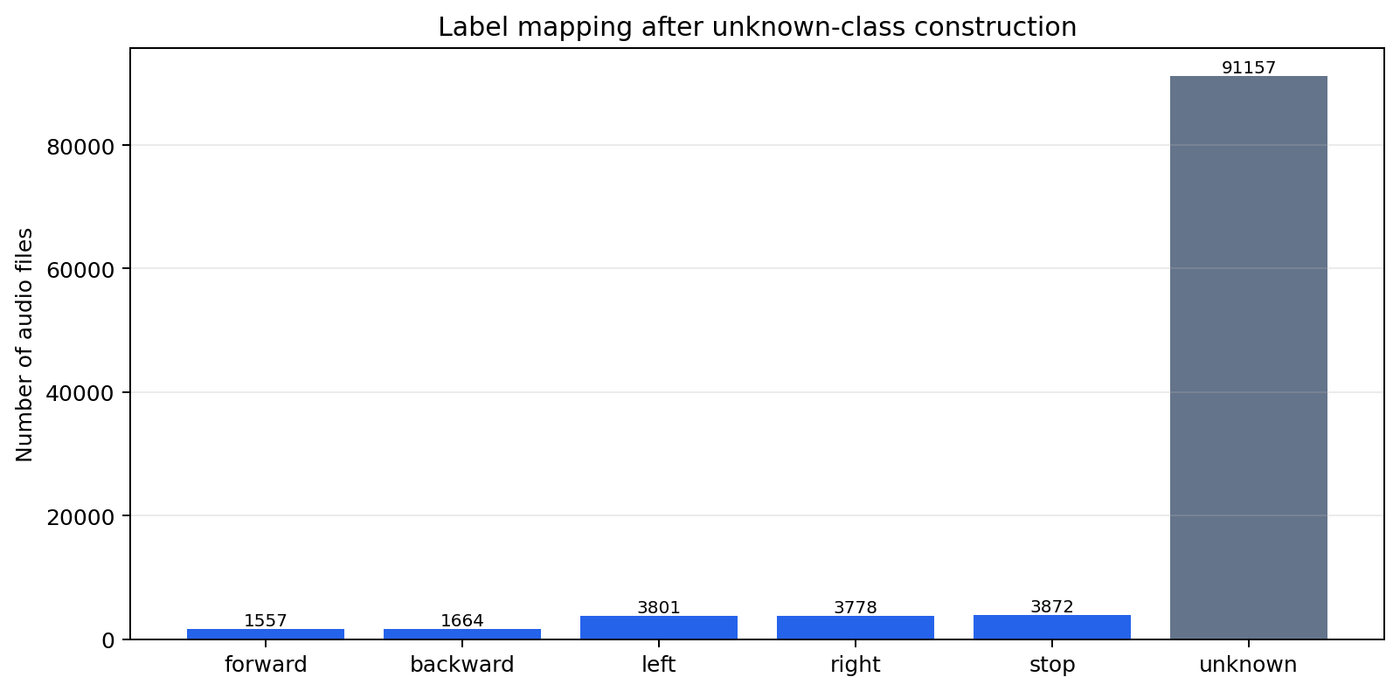

2.3.7. Dataset splitting
- The project uses the official Speech Commands train, validation, and test split.
- Training split: used to train the model.
- Validation split: used to select checkpoint and tune thresholds.
- Test split: used only for final reported results.
- The official split gives a fixed evaluation setting and reduces speaker leakage between training and testing.
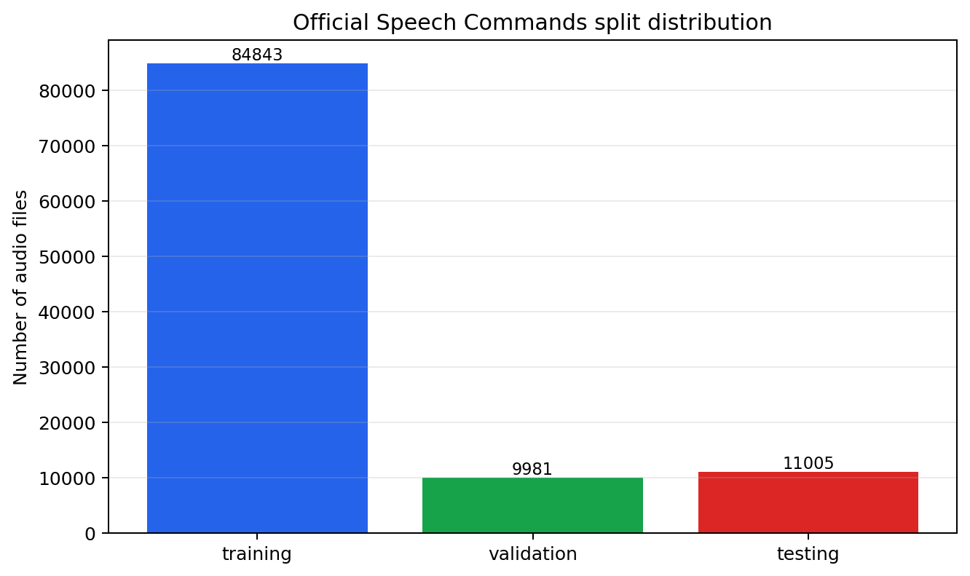
unknown_target = round(average_known_count × unknown_ratio)

2.3.8. Training-only augmentation
- Augmentation is applied only to the training split.
- Validation and test data are not augmented.
- Add noise: simulate room noise or microphone noise.
- Time shift: simulate a command spoken earlier or later inside the recording window.
- Gain change: simulate louder or quieter speakers.
- Purpose: expose the model to more recording conditions during training.
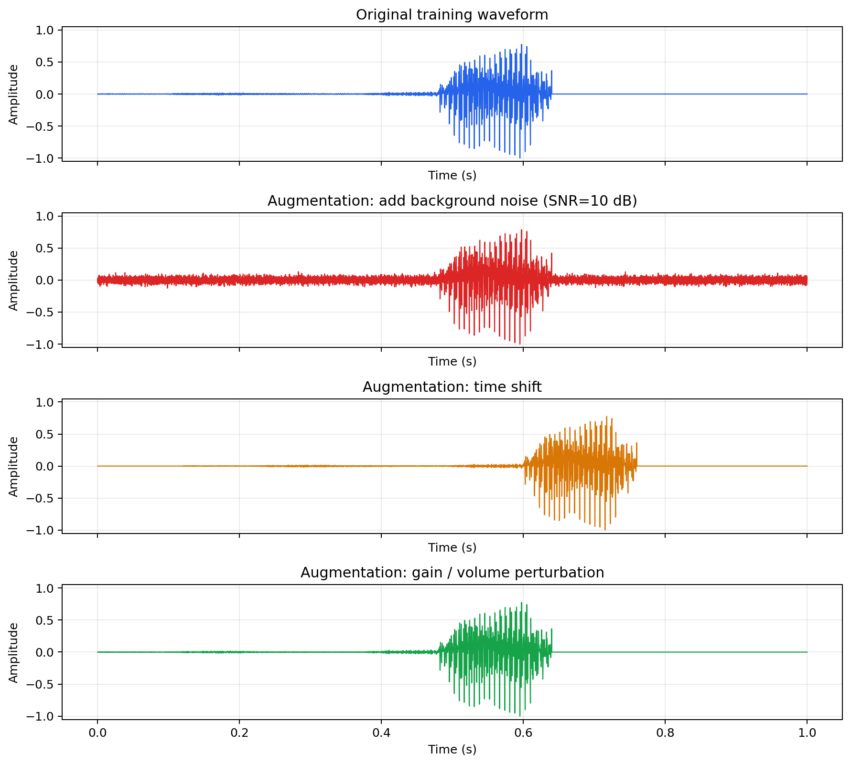

2.3.9. Final feature representation
- After waveform preparation, features are extracted for the model.
- Main model input: Log-Mel spectrogram with 64 Mel bands.
- MFCC is also shown because one baseline uses MFCC + CNN.
- Log-Mel keeps a clear time-frequency structure for CNN and CNN-GRU models.
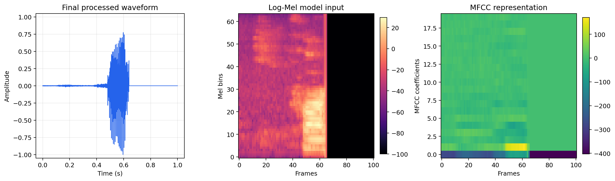
3.1. Proposed System Architecture and Workflow
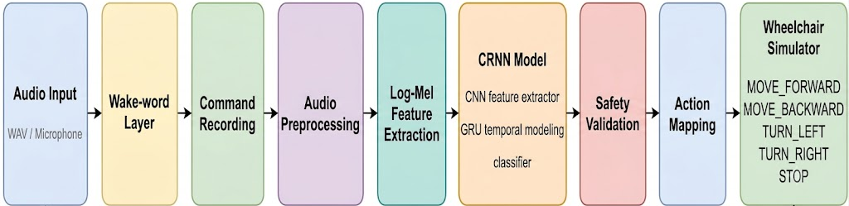

WORKFLOW
Audio Input
→ Wake-word Detection Layer
- OpenWakeWord API
→ Command Recording
- record short command window
- command timeout control
→ Data Preparation
- mono + 16 kHz
- fixed 1-second window
- noise handling + normalization
→ Feature Extraction: Log-Mel spectrogram
- 64 Mel bands
- time-frequency representation
→ Model: CNN-GRU
- CNN layers extract local time-frequency patterns activation (W*x + b)
- GRU layer models temporal order across frames
- pooling/classification layer outputs command logits
→ Prediction Output
- class label
- confidence score
→ Safety Validation
- wake-word/listening state
- confidence threshold
- unknown-command rejection
- allowed command check
- command timeout
- stop command priority
→ Action Mapping
- forward = MOVE_FORWARD
- backward = MOVE_BACKWARD
- left = TURN_LEFT
- right = TURN_RIGHT
- stop = STOP
- Unknown/ rejected command = IGNORE
→ Wheelchair Navigation Simulator
- update position
- update direction
- block movement at map boundary
- log command history

